|  |  |
| --- | --- |
|  | **Database Management Systems**  **BSCS-4**  **Department of Computer Science**  **Bahria University, Lahore Campus** |

**Assignment: [2]**

Date: Week 7, 4th November 2023

Name: _____________________

Roll No: ___________________

|  |  |  |  |
| --- | --- | --- | --- |
| **Evaluation of CLO** | **Question Number** | **Marks** | **Obtained Marks** |
| **CLO: Apply different database model to design conceptual, logical or physical database.** |  |  |  |
|  |  |  |
|  |  |  |
|  |  |  |
|  |  |  |
| **Total Marks** | | **20** |  |

**Question 1**

Professors have a PROFID, a name, an age, a rank, and a research specialty.

Projects have a project number, a sponsor name (e.g. UGC/AICTE/...), and a budget.

Graduate students have an ID, a name, an age, and a degree program (e.g. MCA/ MPhil/BE/ME).

Each project is managed exactly by one professor (known as the project's principal investigator). Each project is worked on by one or more professors (known as the project's co-investigators). Professors can manage/work on multiple projects. Each project is worked on by one or more graduate students (known as the project's research assistants). Graduate students can work on multiple projects. Each professor can supervise many students. A student who is working on a project can be supervised by only one professor. Draw an ERD of the above scenario.

**Question 2**

A University contains many Faculties. The Faculties in turn are divided into several Schools. Each School offers numerous programs and each program contains many courses. Lecturers can teach many different courses and even the same course numerous times. Courses can also be taught by many lecturers. A student is enrolled in only one program but a program can contain many students. Students can be enrolled in many courses at the same time and the courses have many students enrolled.

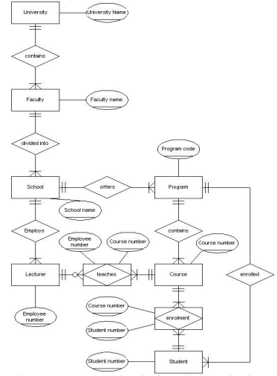

**Question 3**

UPS prides itself on having up-to-date information on the processing and current location of each shipped item. To do this, UPS relies on a company-wide information system. Shipped items are the heart of the UPS product tracking information system. Shipped items can be characterized by item number (unique), weight, dimensions, insurance amount, destination, and final delivery date. Shipped items are received into the UPS system at a single retail center. Retail centers are characterized by their type, uniqueID, and address. Shipped items make their way to their destination via one or more standard UPS transportation events (i.e., flights, truck deliveries). These transportation events are characterized by a unique scheduleNumber, a type (e.g, flight, truck), and a deliveryRoute. Please create an Entity Relationship diagram that captures this information about the UPS system. Be certain to indicate identifiers and cardinality constraints.

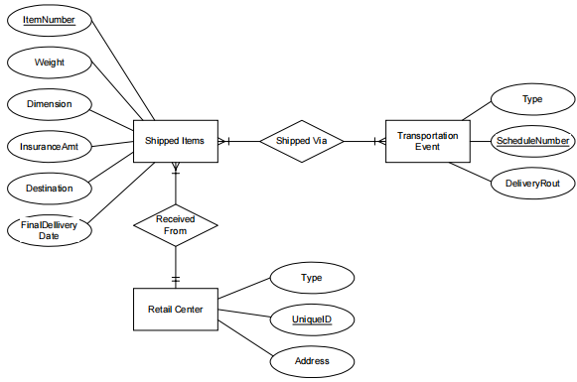

**Question 4**

**CREATING A RELATIONAL DATABASE SCHEMA.**

Production tracking is important in many manufacturing environments (e.g., the pharmaceuticals industry, children’s toys, etc.). The following ER diagram captures important information in the tracking of production. Specifically, the ER diagram captures relationships between production lots (or batches), individual production units, and raw materials.

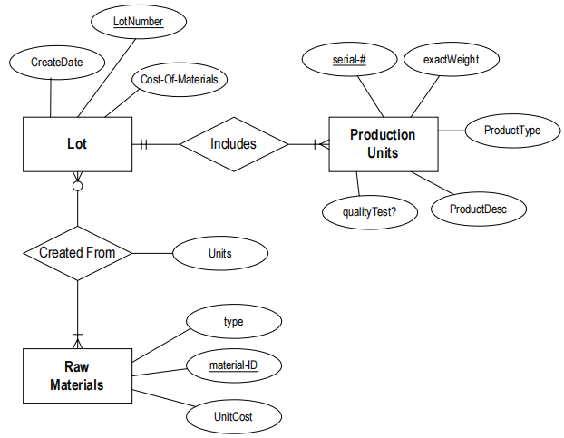

**Note: The following questions refer back to the above ER diagram.**

1. Please convert the ER diagram into a relational database schema. Be certain to indicate primary keys and referential integrity constraints.

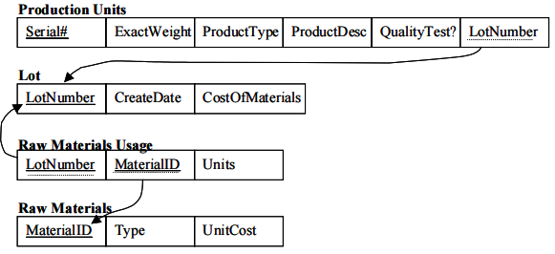

1. Please identify an attribute in the above ER diagram that might represent a composite attribute, and explain why/how it might represent a composite attribute.

**Answer:** Many of the attributes could actually represent composite attributes:

- Weight might be stored as pounds and ounces.

- Product Description might have several components

- Product type might have several components

- Create date might be stored as both date and time.

1. Please identify an attribute in the ER diagram that could represent a derived attribute and explain why/how it might represent a derived attribute.

**Answer:** Cost-of-Materials (associated with the Lot entity) most likely represents a derived

attribute. The cost of materials could be computed based on the materials unit cost (from the

raw materials entity) and the number of units required for a lot (on the relationship).

1. The ER diagram/relational database schema contains several instances of data redundancy. Please identify one instance where a data redundancy issue exists.

**Answer:** Examples include:

- Both production description and product type are being stored for each and every

production unit. The production description could be stored elsewhere.

- Production type and production description are being stored on each and every

production unit, when these parameters are most likely the same for the entire lot.

They could be stored on the Lot entity.